**Defining an Adempiere Financial Report to Print values per BP**

**(or project or product etc)**

**Output of Report**

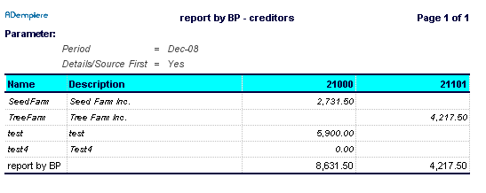

**Creating the Report**

**Define the column set**

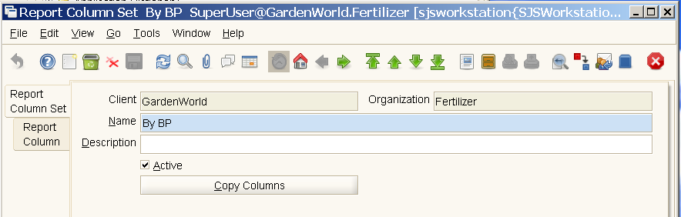

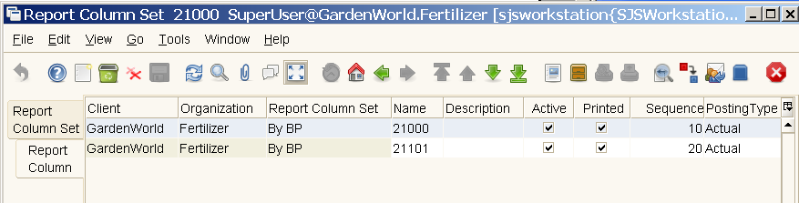

**First column**

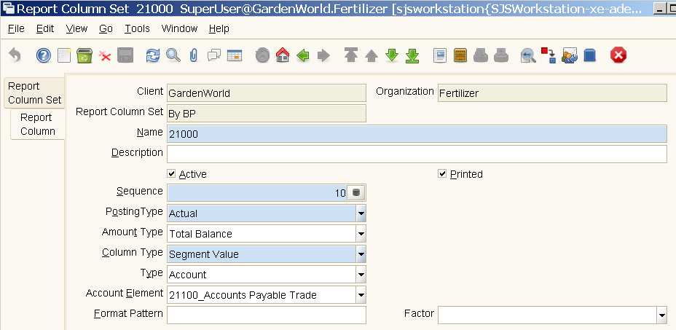

**Second Column**

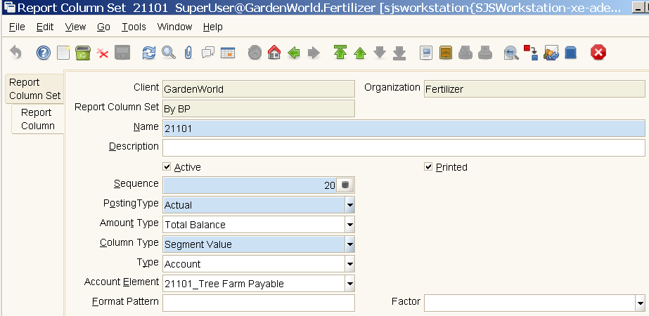

**Then define the Report Line Set - row layout....**

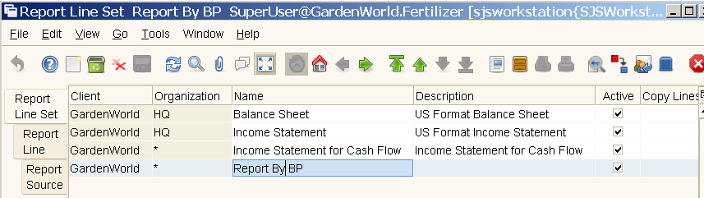

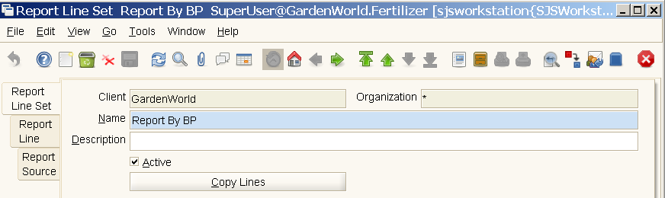

**Define the Report Line**

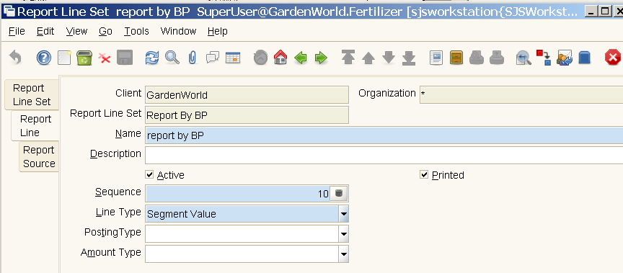

**Define the Report Source**

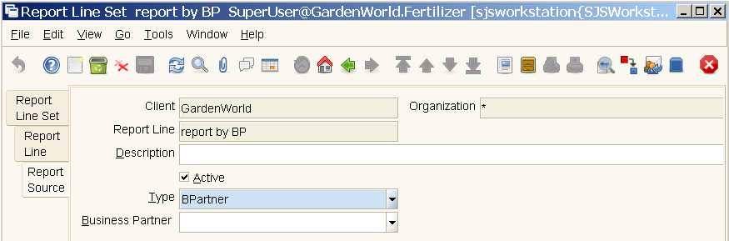

**Create the Financial Report Record**

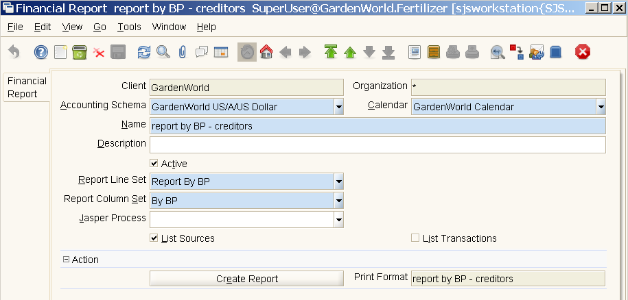

**Run the Financial Report**

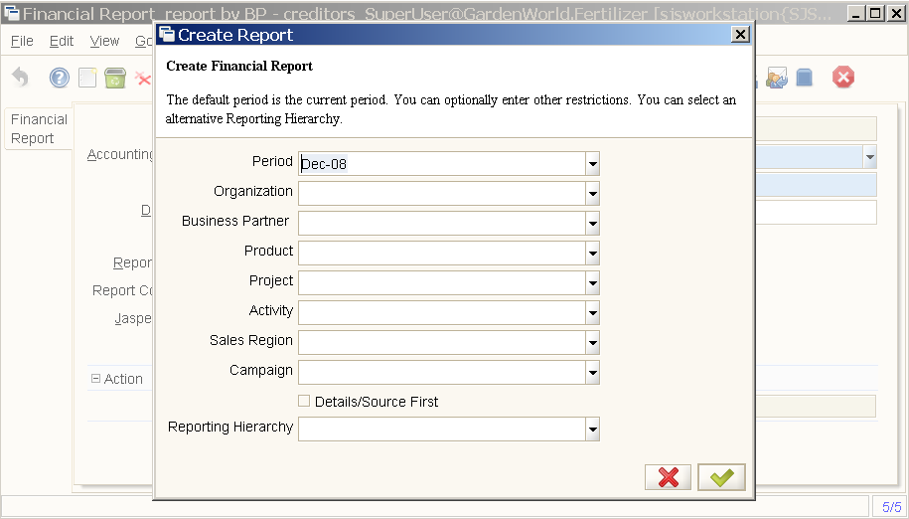

**And get the Output (as before):**



**Example Report of Revenue, COGS and Margin by BP**

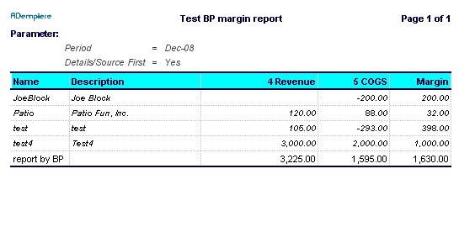

This report was prepared by defining a column for 4_Sales, 5_Cost of Goods sold and a calculated Margin column subtracting COGS from Revenue.

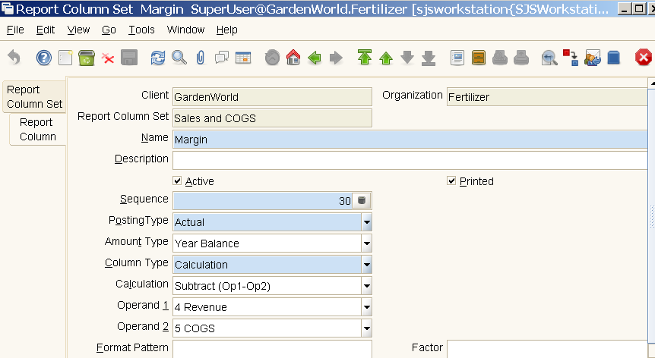

**Notes**

(1) The Vendor “Test4” shows a zero balance in the first report. This vendor had an invoice and a payment in December 2008. Another zero-balance Vendor with an invoice and payment in Sept 2008 is not shown in the report. I don't know if all zero balance vendors are excluded if no trx in current period.

(2) A bug existed that prevented the selection of a Summary Account in the Account Element field of the Report Column tab. It is fixed in 352 (and maybe a bit earlier?)

Regards

Adaxa